BULLETIN FROM THE KOTLAS
CONNECTION CHAIRS
Issue #44 January, 2015

2015 DUES ARE NOW DUE – Still only $10 folks –
Don’t you just love a bargain?
If there is an envelope enclosed with this issue of the Bulletin your membership dues are due!
Please send your check to The Kotlas Connection, P.O. Box 1747, Waterville, Maine 04903-1747.

COMEDY FILM SERIES IN THE OFFING

The Connection is pleased to announce its fourth film series in conjunction with Mid-Maine Regional Adult Education. In the past the series has featured historical films, social commentary films, and War and Peace. This year we will keep it light with a grouping of five (5) classic comedic films featuring some of the favorite characters of Russian comedy cinema.

The films include two romantic comedies – A Business Romance and The Irony of Fate. For lovers of farce we include two slapstick comedies – Peculiarities of National Fishing and Operation Y and Other Adventures of Shurik. And we will take a cinematic time travel adventure with Ivan Vasil’evich Changes His Profession.

Our sixth and last meeting will feature a home-made Russian dinner, always a delicious meal, with recipes prepared by everyone in the group.

We hope you will register for this Adult Education course and join us for this entertaining six weeks. The class will meet on Tuesday evenings at Waterville High School from 6-8 pm beginning March 31st and ending on May 12th. There will be no session on April 21st.

You may register for the course by calling the Mid-Maine Regional Adult Education office at 873-5754 or by going on-line at www.midmaine.maineadulted.org. The fee for the course is $29.00.

22nd ANNUAL RUSSIAN SAMPLER

The Connection and the Colby College Russian Program are preparing for their 22nd Russian Sampler Day for central Maine middle and high school students. This program has always been an exciting day for students who come to Colby College for a day of learning about Russian history, language, and culture. Students elect three classes from a list which includes sessions on the Waterville area’s sister city of Kotlas, Russian religious art and the Russian Orthodox Church, Russia’s education system, favorite Russian sports, conversational Russian, the life of Samantha Smith, school girl diplomat, Russian fairy tales, and favorite Russian cartoon. Many of the sessions are hands-on craft projects and cooking classes.

One of the highlights of Sampler is a chance for American students to meet and learn from visiting students and their teacher from Kotlas. This year two of the students will talk about folk dance and teach their American counterparts one popular Russian folk dance.

We thank all the generous volunteers who lead our sessions and help the students during the day at Colby. If you would like to contribute a topic or your time and effort in support of this program, please send a note to Professor Elena Monastireva-Ansdell at the Colby College Russian Program. She can be reached via e-mail at eimonast@clby.edu. Especially at this tense time in US-Russian relations our young students need to learn about Russian history in order to better understand today’s Russia. We welcome all participating schools to this year’s Russian Sampler.

ELECTION RESULTS FROM THE ANNUAL MEETING

At the annual meeting on November 19, 2014 the membership elected the following to lead the Kotlas Connection for 2015:

Martha Patterson will continue in her two-year term as Co-chair.
Mary Coombs was elected for a two-year term as Co-chair.
Sheila McCarthy was elected for a two-year term as Secretary.
Carl Daiker will continue in his two-year term as Treasurer.

Elected to one-year terms on the Executive Committee were:

Ellen Corey
Mark Fisher
Phil Gonyar
Pauline Mayhew
Joseph Couture
John Engle
Herb Foster
Marilyn Hall
Ex-officio
Waterville Mayor Nick Isgro
SISTER CITY CONNECTION HISTORIC 25TH ANNIVERSARY

The members of the Kotlas-Waterville Area Sister City Connection have extended a warm invitation to Kotlas Mayor Andrey Bralnin, members of his administration, and members of the Waterville Committee to come to Waterville in June to celebrate the 25th anniversary of friendship.

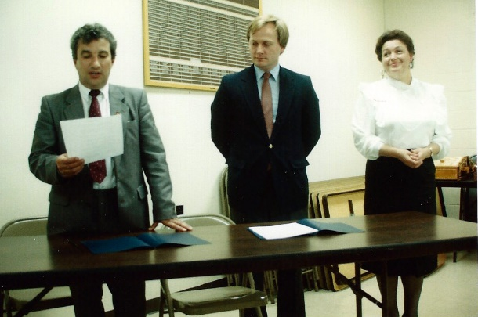
On June 20, 1990 the mayor of Kotlas and the mayor of Waterville signed an agreement to establish a sister city relationship. Over the years that relationship has flourished resulting in many exchanges of city officials, doctors, teachers, social workers, high school students, and friends.
Figure 1 Signing of the Sister City Agreement, Waterville, June 20, 1990 - Pictured from the left Victor Zverev, Mayor of Kotlas; David Bernier, Mayor of Waterville; Zinaida Egorova, Kotlas delegation member

We look forward to the celebration to greet our friends once again with a spirit of hope between our two countries, especially during this time of political unrest. We are grateful for the opportunities we have been given to establish peace, one person at a time, with our friends in Russia.

DELEGATION GOING TO KOTLAS

This April, as part of the 25th Anniversary of the official establishment of our sister city relationship, there will be a delegation of Waterville area residents traveling to Kotlas. Connection Co-chairs, Martha Patterson and Mary Coombs; Board Member, Mark Fisher; Peter Garrett, an original founding member; and Tessa Couture, daughter of Board Member, Joe Couture, will represent our city.

Through much of the 1980s Peter Garrett had been trying to establish a sister city relationship between the Waterville area and a Russian city in an effort to dispel some of the political tension that existed at that time between the United States and what was then the Soviet Union. For a number of logical reasons Kotlas had been selected as a likely sister city. Early efforts to establish an official connection had met with very limited success. Kotlas was considered by the Soviet Union to be a “closed” city to foreign visitors. The best that had been accomplished up to that point was the creation of pen pals between Waterville-area students and Kotlas-area students. With a lot of persistence and the help of Russian-speaking, Waterville resident Natalia Kempers, a correspondence was established in 1986 between Vyacheslav Chernykh, a Kotlas boatyard engineer and amateur stamp collector, and Natalia. This “breakthrough” eventually resulted in the establishment of pen pals among Waterville-area and Kotlas-area school students.

In 1989 Mary Coombs led a group of 19 Winslow students and other adults on a school trip to Moscow and St. Petersburg. They were not allowed to travel outside of those two cities. The students on the trip all had pen pals in Kotlas. Peter, Natalia, and Peter’s daughter, Jessica, were part of that trip. While in Russia the three were able to arrange a side trip to Kotlas. They were, in fact, the first Americans to ever visit Kotlas. The Winslow students were delighted to receive letters and gifts from their pen pals when Peter et al rejoined the main group in St. Petersburg. One year later an official delegation from Kotlas arrived in Waterville to sign the agreement establishing the sister city relationship.

The delegation visiting Kotlas in April will conduct sessions for students of English at their American Sampler. American Sampler is the Kotlas equivalent of Russian Sampler held each year at Colby for American middle school and high school students.

The Waterville delegation will also be carrying invitations for a mayoral delegation from Kotlas to come to Waterville this June as part of the 25th Anniversary. In these times of difficulties between our governments it is nice that our friendship between people continues to be strong.

ANOTHER SUCCESSFUL ORNAMENT SALE SEASON

In addition to selling our Russian-made Christmas ornaments at the holiday craft fairs at Temple Academy and Waterville High School, Kennebec Federal Savings (KFS) and Jorgensen’s Café once again allowed the Connection to display and sell ornaments. We are very appreciative of KFS and Jorgensen’s continued support of our fund-raising efforts. Sales from the three venues totaled $775. Sales were slightly hampered by inclement weather on the two Saturday’s of the craft fairs.

WANT TO KNOW MORE?

For more information on the Connection’s activities and a detailed history of the establishment of the Connection, please visit our web site at http://www.kotlas.org.

