**BULLETIN FROM THE KOTLAS**

**CONNECTION CHAIRS**

**Issue #42 January, 2014**

**2014 DUES ARE NOW DUE – Still only $10 folks –**

**Don’t you just love a bargain?**

**If there is an envelope enclosed with this issue of the Bulletin your dues are due!**

Please send your check to The Kotlas Connection, P.O. Box 1747, Waterville, Maine 04903-1747.

**JACK MAYHEW MEMORIUM**

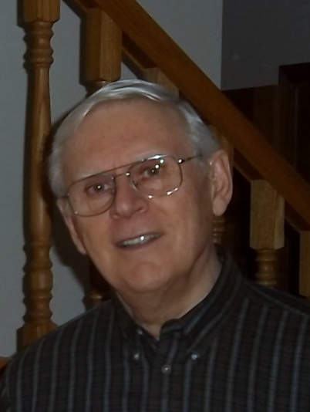We are greatly saddened by the death of our dear friend and Executive Committee member, Jack Mayhew, who devoted the last 23 years to the founding and nurturing of our Sister City relationship with Kotlas. Jack worked tirelessly and meticulously and always with his gentlemanly good spirits on every exchange, in every Russian Sampler, at every Annual Meeting, and on every tour of Maine for Russian guests. Our partners in Kotlas, who often hosted Jack at their apartments and dachas, share our grief at the loss of one of their most beloved American friends.

In a letter of condolence to Jack’s wife, Pauline, The Waterville Committee in Kotlas writes that "*our thoughts and prayers are always with you. ... We will always remember Jack as an honest and cheerful man, who loved to joke. ... Everybody here in Kotlas, who had a beautiful chance to meet Jack, will never forget his amazing sense of humor and his great gift for storytelling.*"

Jack Mayhew served in the US Navy and later worked at both Grenier and Hanscomb Air Force Bases as a civilian employee. Jack retired from the Xerox Corporation after 30 years work as Field Manager for much of the state of Maine. While still working and then in retirement, Jack devoted much time and energy to the Sister City Committee, serving as its Co-Chair for 7 years and accepting the role as Chief Coordinator of the Open World teacher exchange in 2008. In 2013, when the Open World delegation of social services workers visited, Jack arranged and coordinated several of their site visits with aplomb and his ever-warm smile. Jack and Pauline Mayhew were honored with a REM Volunteers Service Award in 2006.

During the years of the Cold War and the later years of thawing relations with the Soviet Union and Russia, there could not have been a better personal representative of American hospitality, grace, energy, and "getting the job done" than Jack. We mourn his loss.

**CONNECTION INVITED TO MAKE PRESENTATION AT MID-MAINE GLOBAL FORUM**

“The Mid-Maine Global Forum was founded in 1997 by Linda K. Cotter to promote the discussion of international affairs in Central Maine. Our non-partisan group organizes lectures, study groups and discussions on timely global topics. Events, usually around lunch, are open to the public.” (Global Forum Website)

The members of the Kotlas Connection have been invited by the Mid-Maine Global Forum to make a lunch-time presentation on the work of the Connection. The presentation is tentatively scheduled for Wednesday, March 19, 2014 at 11:45 AM in the Forum of the The Center (93 Main Street) in downtown Waterville. The timing of the presentation was designed to coincide with a visit for Russian Sampler by a teacher and two high school students from Kotlas. Please watch the *Morning Sentinel* for more details on this event including confirmation of the date.

**ELECTION RESULTS FROM THE ANNUAL MEETING**

At the annual meeting on November 13, 2013 the membership elected the following to lead the Kotlas Connection for 2014:

Martha Patterson was elected to a second two-year term as co-chair.

Carl Daiker was elected for a second two-year term as treasurer.

Sheila McCarthy will continue in her two-year term as Secretary.

Elected to one-year terms on the Executive Committee were:

Mary Coombs

Ellen Corey

Mark Fisher

Phil Gonyar

Jack Mayhew

Pauline Mayhew

Joseph Couture

John Engle

Herb Foster

Marilyn Hall

Ex-officio

Waterville Mayor Karen Heck

Since the election long-time member and past co-chair Jack Mayhew has passed away (see related memorium). This leaves your Executive Committee with only 13 members one of whom is ex-officio member Waterville Mayor Karen Heck. The Executive Committee can function with 12 members, but the workload will obviously be heavier than it was when we had 16 members as recently as three years ago. It is hoped that some of the members-at-large will volunteer to serve on the Executive Committee, even on a trial basis. The Committee meets on the at 5 PM on the first Wednesday of each month (except July and August) at The Center, 93 Main Street, in downtown Waterville. Meetings generally last approximately one hour. Those interested should contact Co-chair Martha Patterson at 207-872-5935 (Home) or 207-649-5280 (Cell) or at mrthpatterson@gmail.com. ***Please give joining the Executive Committee some serious thought.***

**TEACHER AND TWO STUDENTS INVITED TO RUSSIAN SAMPLER 2014**

The Connection is pleased to announce that our 21st annual Russian Sampler day for area middle school and high school students will be held at Colby College on Monday, March 24, 2014. The Connection and the Colby College Russian Program join forces each year to welcome 250 area students for a day of learning about Russia. Connection members begin the students’ day with an Opening Assembly, which presents basic facts about Russian geography, history, government, and schools to give the students some background for their three classes during the day. Then students attend classes, for which they have preregistered in their schools. Our sessions include various crafts, music, cooking, religious art, sports, historical events, language, films, schools, and photo tours of Kotlas, our Russian Sister City.

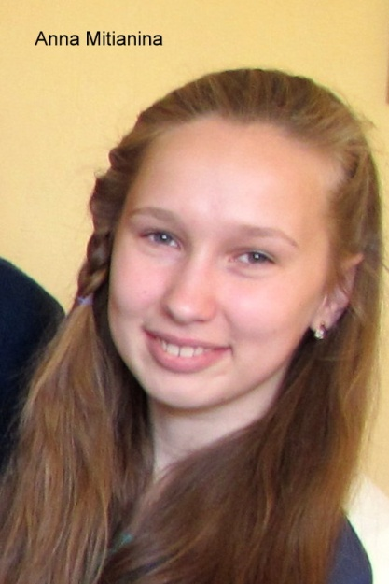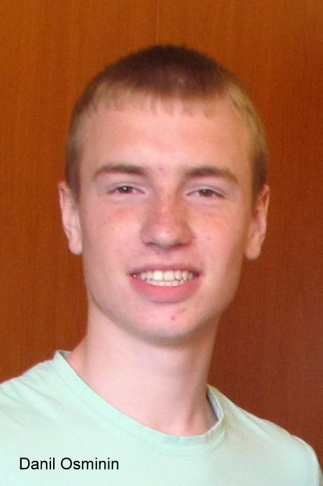One highlight of Sampler is the presence of guests from Kotlas, who join our 25 presenters as leaders of sessions. This year we will welcome English teacher Anna Lobanova, who will lead a session on Russian “dachas” (beloved summer cottages); Russian high school student Anna Mitanina, who will lead a session on Russian schools; and Russian high school student Danil Osminin, who will give students a taste of Russians’ favorite sports. Another highlight of the day is the sampling of the Russian treats prepared during the morning in the cooking classes.

We look forward to another exciting Russian Sampler this year, and, as always, we are grateful to the teachers at all the schools, who handle the students’ registering for sessions, and to the presenters, who prepare and teach informative and active classes for the students.

If you would like detailed information about Sampler, please contact Professor Elena Monastireva-Ansdell at the Colby College Russian Program. <eimonast@colby.edu>

**ORNAMENT SALES**

C:\Documents and Settings\Administrator\Local Settings\Temporary Internet Files\Content.IE5\P19DJGC5\MC900082883[1].wmfThe Connection had a very successful year selling Russian-made Christmas ornaments at a number of venues in the Waterville area. We are grateful to Jorgenson’s Café for allowing us to set up a small Christmas tree to display the ornaments for sale. We are also grateful for the continued support of the two branches of KFS (Kennebec Federal Savings Bank) in our sales effort. The sales at Temple Academy and Waterville High School holiday fairs were also beneficial to the Connection’s coffers. We are working on obtaining a new supply of ornaments for the 2014 sale.

**WANT TO KNOW MORE?**

For more information on the Connection’s activities, please visit our web site at <http://www.kotlas.org>.